in the news

Les Amis
Debussy • Caplet
Elizabeth Hainen, harp
Jeffrey Khaner, flute
Roberto Diaz, viola
Michael Stern
IRIS Orchestra
AV 2285

The Irish Times
3 January 2014



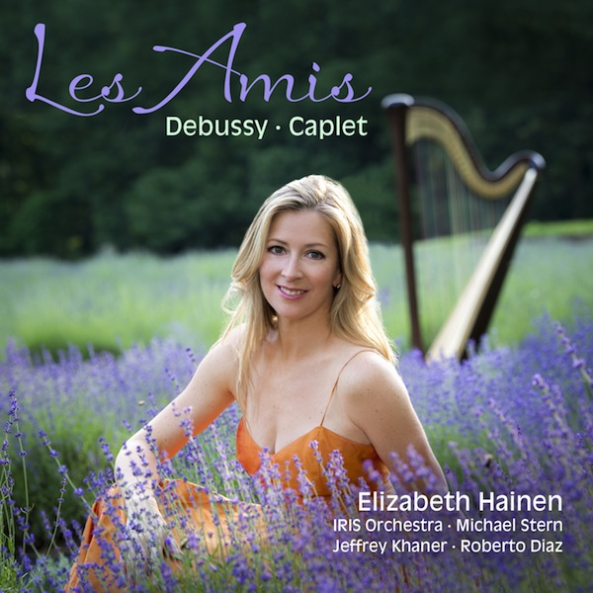
This is a disc of music, written by two early 20th-century friends and performed by a group of 21st-century friends, focused around Elizabeth Hainen, solo harpist of the Philadelphia Orchestra. If that description suggests a sense of indulgence, it’s a suggestion that the sheer sensuality of the music-making fully bears out. Debussy’s Danse sacrée et danse profane sounds utterly gorgeous, and Hainen’s handling of her own arrangement of the Petite Suite is good enough to allow you forget it was originally for piano duet. The approach to the Sonata for flute, viola and harp is time-stillingly luscious. And the performances of Caplet’s Divertissements and the Poe-inspired, presciently horror-flickish Conte fantastique will surely win the composer new friends.

- Michael Dervan

